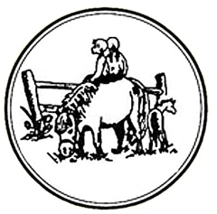
Maryland Pony Breeders
Annual Meeting & Awards Banquet
Sunday January 29th, 2023
11am-2 pm
Broken Spoke Winery
(owned by Rob & Thea Hall)
942 Glebe Rd
Earlsville, Maryland 21919

Silent Auction Items Needed – All donations greatly appreciated. Funds raised from the auction are used to promote and assist the Futurity portion of our Annual Show.
For silent auction information, please contact Jean Greenlee locustgrovefarm@hotmail.com

Adults: $35 (cash bar)
Children 3-10: $15

Total Number of tickets: adults: ______ children: ______ Total Amount: _$__________

Please list names of those attending__________________________________________

Send checks payable to MPB Inc. to:
MPB
PO Box 2106
Easton, MD 21601
locustgrovefarm@hotmail.com

Brunch Schedule:
11:00 – 11:30 Registration & Silent Auction Start
11:30 – 12:30 Brunch
12:30 – 1:00 Annual Meeting
1:30 - Silent Auction ends
1:00 – 2:00 Awards

